**GIT AND GIT HUB**

1)Install git.

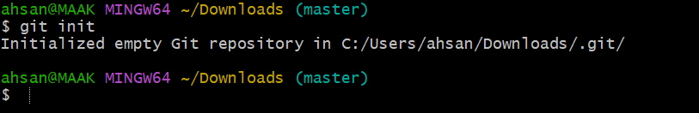

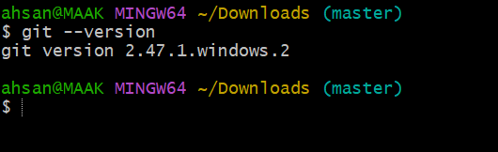

2)Create a repo in github with README.md and .ignore file.

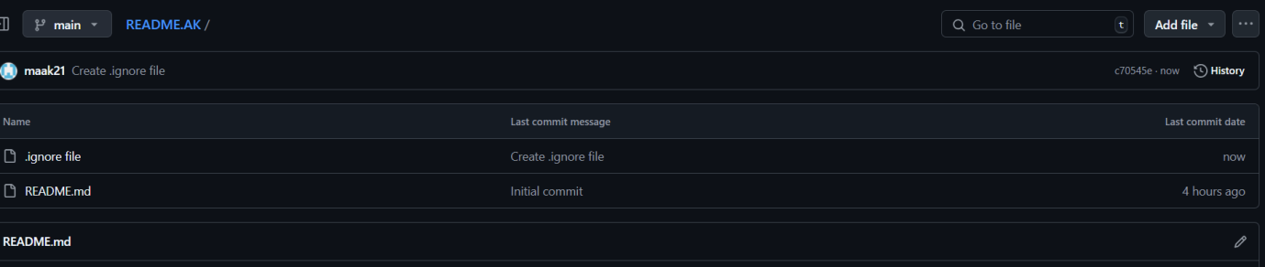

3)Clone the created repo to local.

• Go to your repository on GitHub.

• Click the **"Code"** button (usually green) on the repository page.

• Copy the URL provided:

* For HTTPS:

https://github.com/maak21/README.AK.git

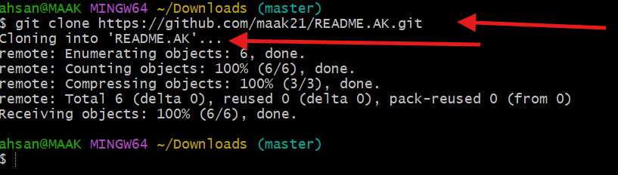

4)Create two files in local repo.

cd README.AK

touch frist second

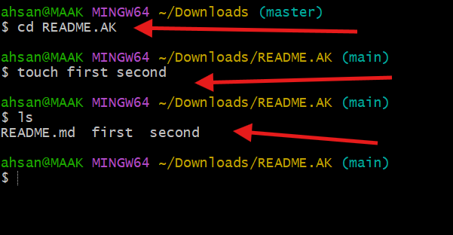

5)Commit two files and push to central Repository.

First check status of git

Git status

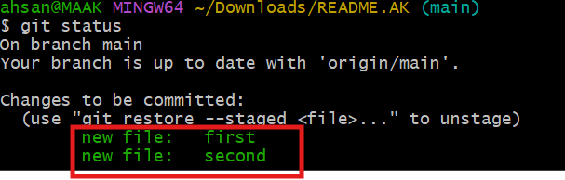

git commit -m "Added files: frist and second"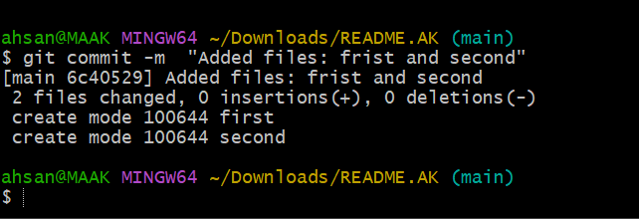

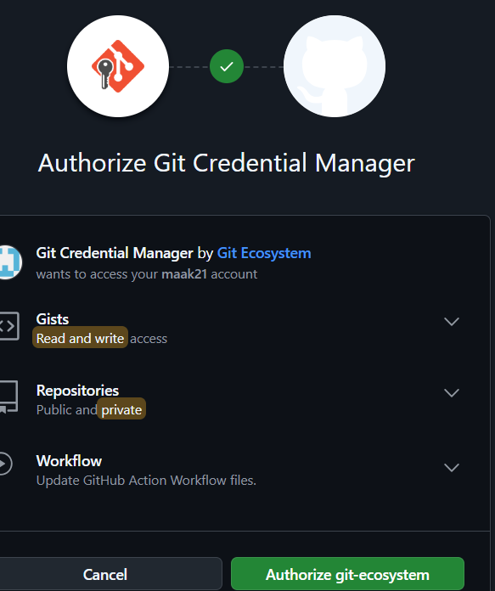

git push origin main

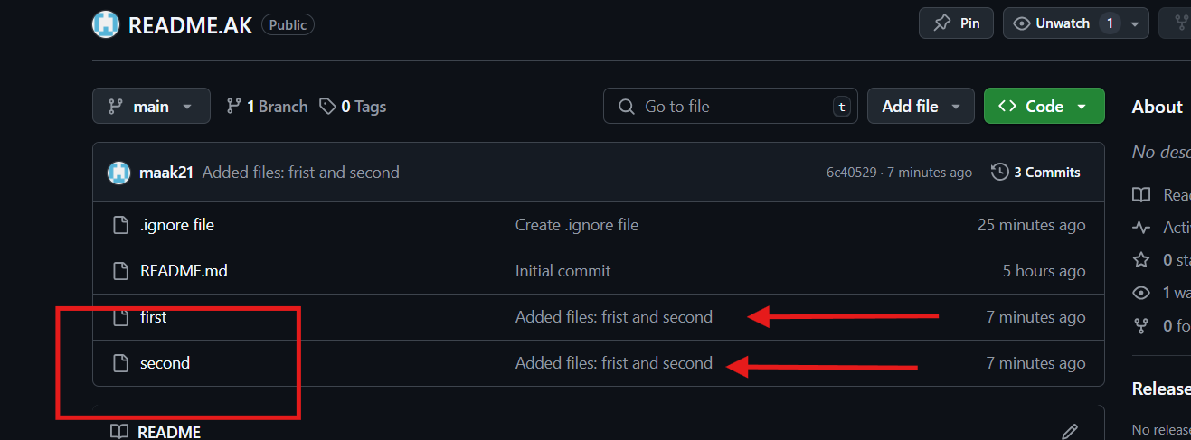

6)Create a branch in local and create a sample file and push to central.

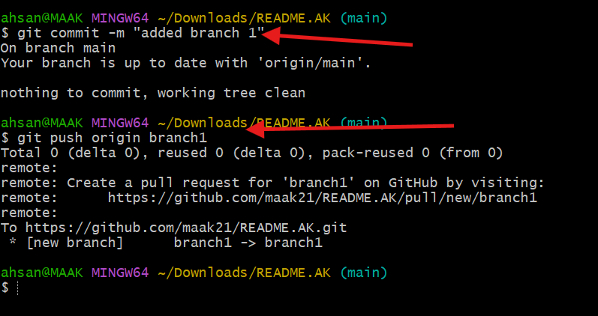

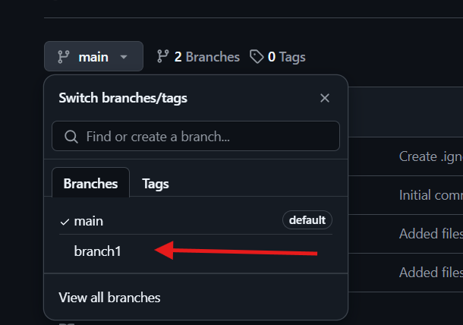

7)Create a branch in github and clone that to local.

**Step 1: Create a Branch in GitHub**

1. Go to your repository on GitHub.
2. Click the **"Code"** tab to view your repository files.
3. Look for the branch dropdown (usually says main) and click it.
4. In the text field, type the name of the new branch (e.g., new-branch) and press **Enter**.
   * Ensure the "Create branch" option is selected when pressing Enter.

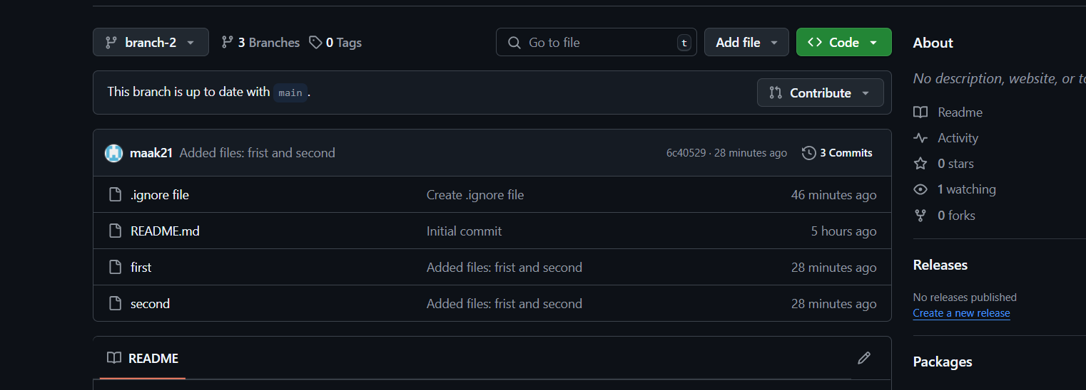

### ****Step 2: Clone the Repository Locally****

If you haven’t cloned the repository yet:

1. Copy the repository URL from the **Code** button.
2. Open **Git Bash** and run:

Step 3 git clone https://github.com/maak21/README.AK.git

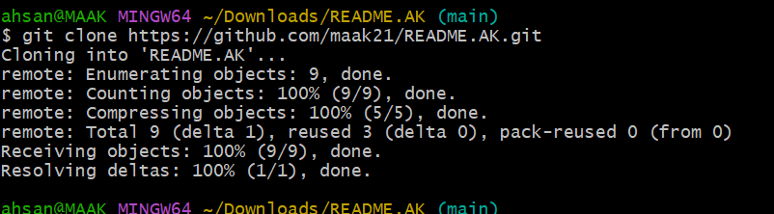

### ****Step 3: Checkout the New Branch****

Now that the repo is cloned:

1. Fetch the latest branch information:
2. • git fetch

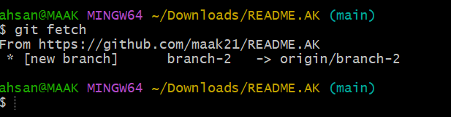

git checkout branch-2

git branch

git branch –-list

git commit -m README.AK

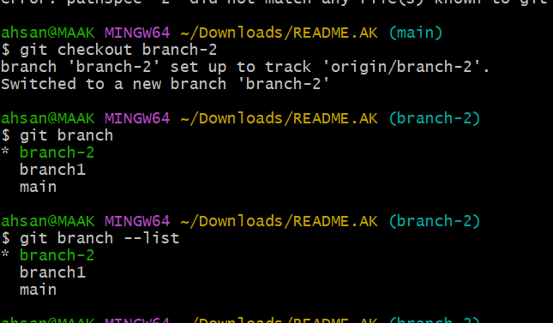

**8)Merge the created branch with master in git local.**

### Step 1: Switch to the main Branch

First, make sure you’re on the main branch where you want to merge the changes:

Switch to main brach

$Git checkout main

$ git merge brach-2

Updating 6c40529..cda8c69

Fast-forward

README.AK | 1 +

1 file changed, 1 insertion(+)

create mode 160000 README.AK

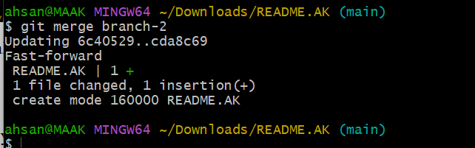

**9)Merge the created branch with master in github by sending a pull request.**

### Step 1: Go to the Repository on GitHub

1. Open your repository on GitHub (e.g., README.AK).
2. Ensure your changes have been pushed to the remote branch (e.g., branch-2).

### Step 2: Start a Pull Request

1. Click the **"Pull requests"** tab in your repository.
2. Click the **"New pull request"** button.

### Step 3: Select the Branches

### 

1. In the "base" dropdown, select main (this is the branch you want to merge into).
2. In the "compare" dropdown, select branch-2 (the branch you want to merge from).

### Step 4: Create the Pull Request

1. Review the changes below to ensure everything looks correct.
2. Add a title and description for your pull request.
   * For example: **Title**: "Merge branch-2 into main"
   * **Description**: "This pull request includes [brief description of the changes]."
3. Click **"Create pull request"**.

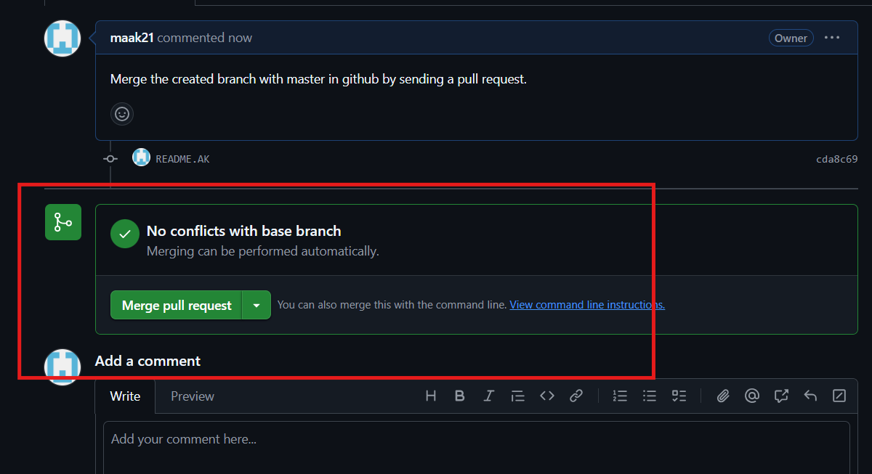

### tep 5: Review and Merge

1. If the repository is yours, you can review and merge the pull request yourself:
   * Click **"Merge pull request"**.
   * Confirm the merge by clicking **"Confirm merge"**.
2. If there are conflicts, GitHub will notify you. Resolve them in the web editor before merging.

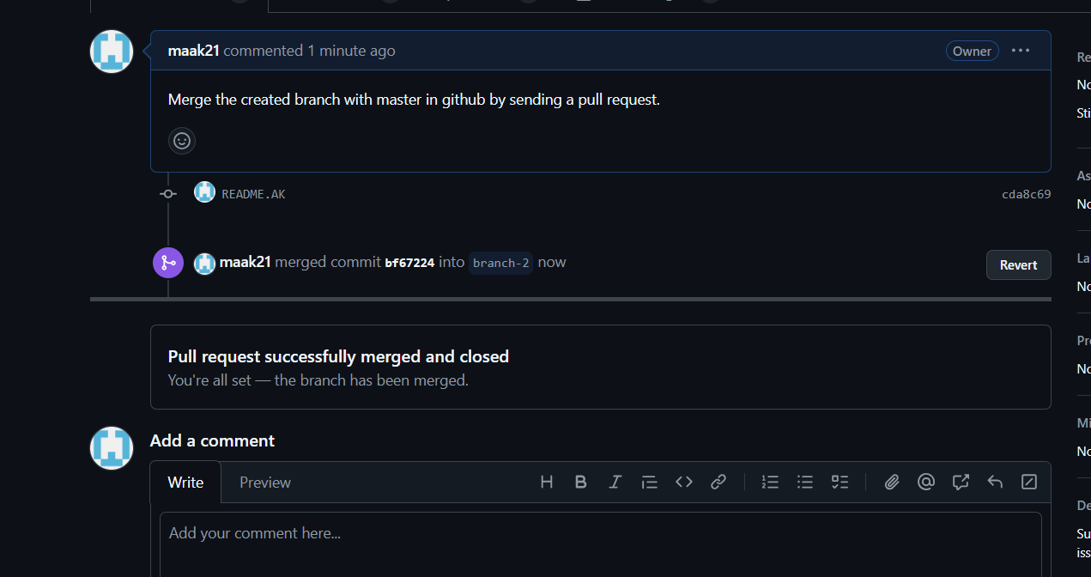

**10)create a file in local and send that to branch in github.**

Step 1

Git checkout branch -2 ( switch to branch-2)

Touch sample 1 ( created file name sample)

Git add . ( save and excecute)

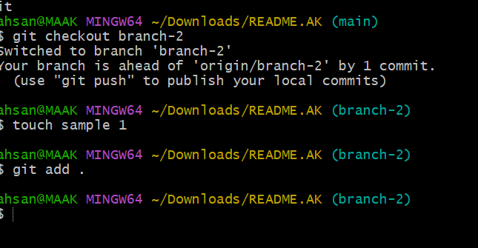

git commit -m "adding sample1 in branc2"

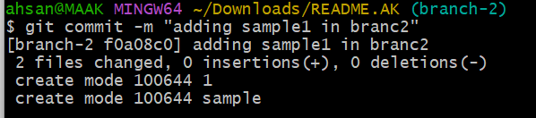

Fetch and integrate the remote changes into your local branch-2:

bash

git pull origin branch-2 –rebase

After successfully rebasing

git push -u origin branch-2

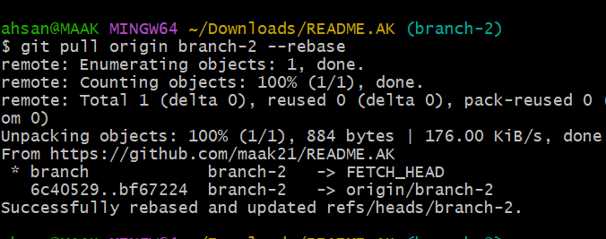

Here we created a file in local and push it to centeral repository of branch2

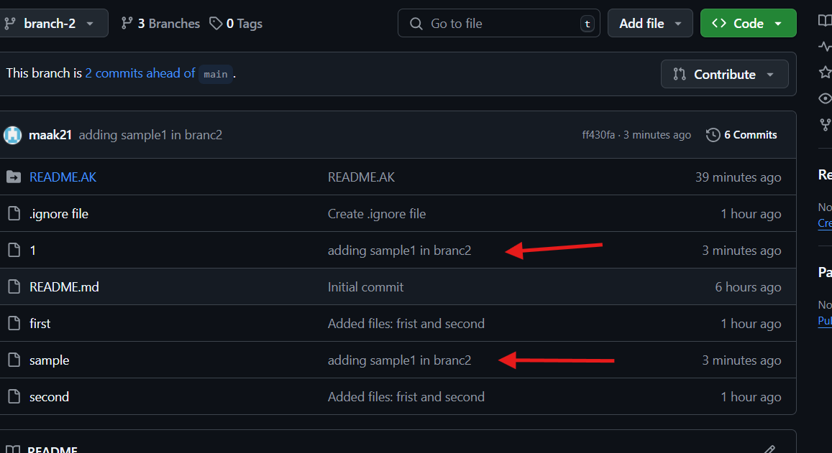

11)clone only a branch from github to local.

Herer what we did clone from github to local

Step1 to switch brach 2

Step 2 for below command mention specific branch name ex: branch 2 then url then give new directory name

git clone --branch branch-2 --single-branch https://github.com/maak21/README.AK.git githubtolocalbrachclone

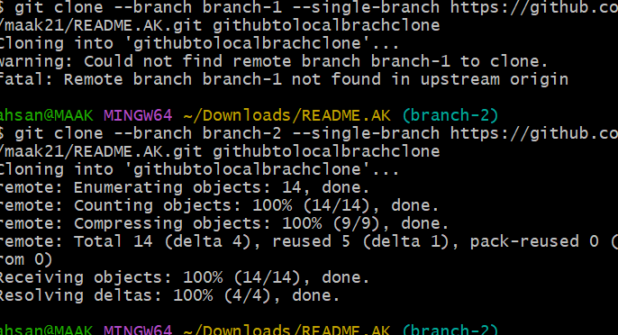

Some are untrack files there now , and git fetch is used now

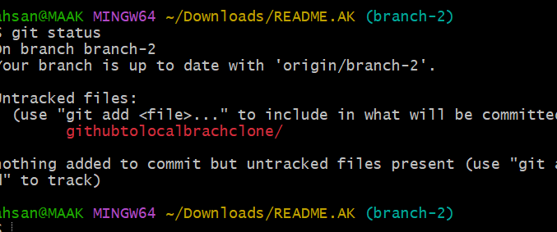

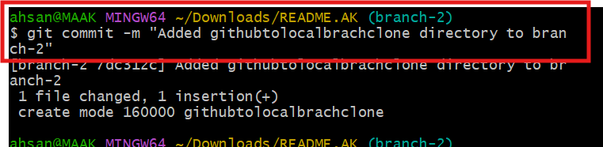

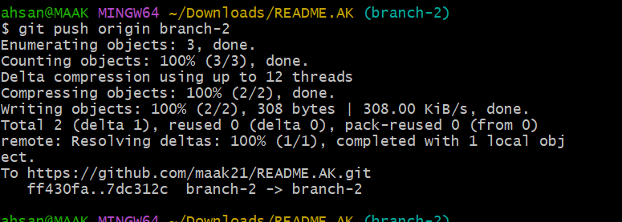

12)create a file with all passwords and make that untrackable with git.

**tep 1: Remove the File from Git Tracking**

Even though the file is currently tracked, you can stop Git from tracking it while keeping it in your local system:

bash

git rm --cached password.txt

vi. .gitignore

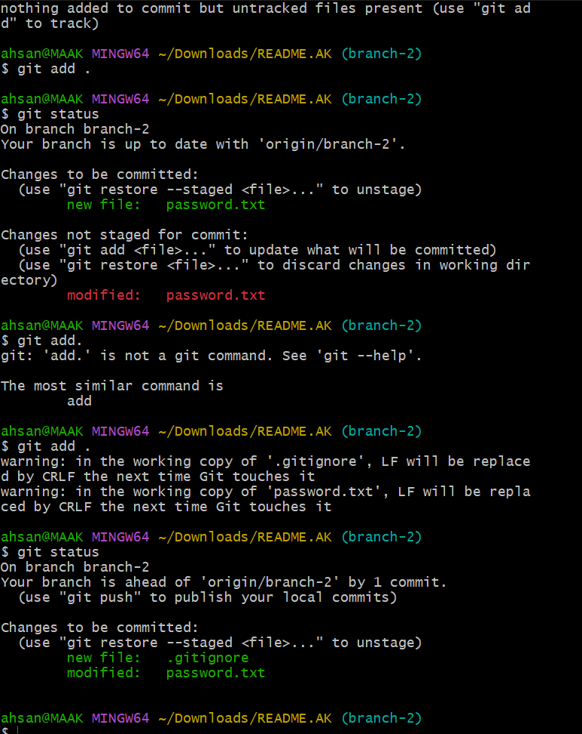

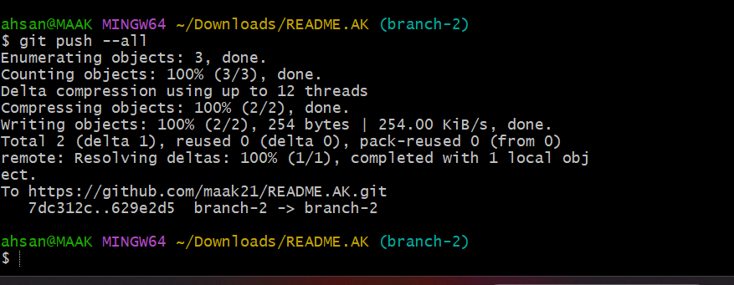

13)make a commit and make that commit reset without savings changes.

14)Revert a commited commit to the older version.

15)push a file to stash without savings the changes and work on another file.

16)undo the stash file and start working on that again.

17)generate a ssh-keygen and configure into github.

18)configure webhooks to github.

19)basic understanding of .git file.

20)Check all the logs of git.

21)Rename the commit message.

22)Merge multiple commits into single commit.